

100 DAYS RTL PART-1

Day 11: To verify t-flipflop

Day 12: To verify binary shift register

Day 13: To verify mealy fsm

Day 14: decimal to binary converter

Day 15: to verify 3:8 decoder

Day 16: t0 verify 1:8 de-mux

Day 17: to verify 4-bit alu

Day 18: binary to gray code converter

Day 19: gray to binary code converter

Day 20: to verify logic gates

Day 11: To verify T flipflop:
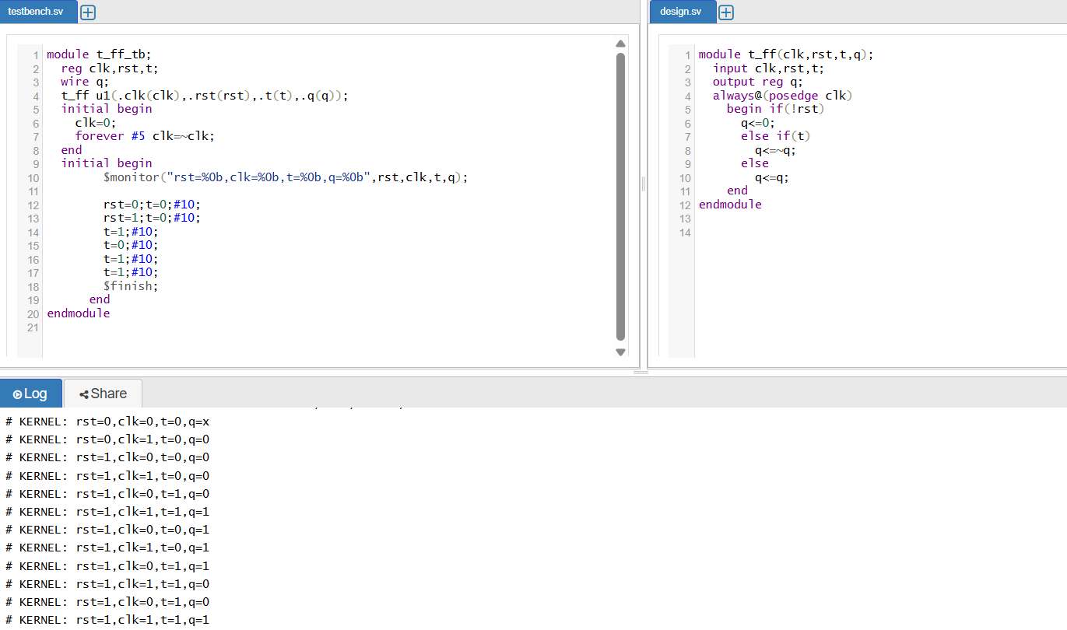

T (toggle) flip-flop is a sequential logic circuit that toggles its output Q on each active clock edge when the input T = 1, and holds its state when T = 0.
⚙️ Key Features
- Single input toggler
  - T = 0 → No change: Qₙ₊₁ = Qₙ
  - T = 1 → Toggle: Qₙ₊₁ = ¬Qₙ
- Truth Table
T | Qₙ | Qₙ₊₁
0 | 0 | 0
0 | 1 | 1
1 | 0 | 1
1 | 1 | 0
- Characteristic Equation
Qn+1=T⊕Qn Q_{n+1} = T \oplus Q_nQn+1​=T⊕Qn​
(XOR of T and current state)
⏱️ Timing Behavior
Edge-triggered: toggling happens only on clock's rising (or falling) edge when T = 1. When T = 0, Q remains unchanged.

🧠 Applications
- Frequency divider.
- Counters & Flip-Flop chains
- Control and timing circuits

Day 12: To verify Binary Shift Register:

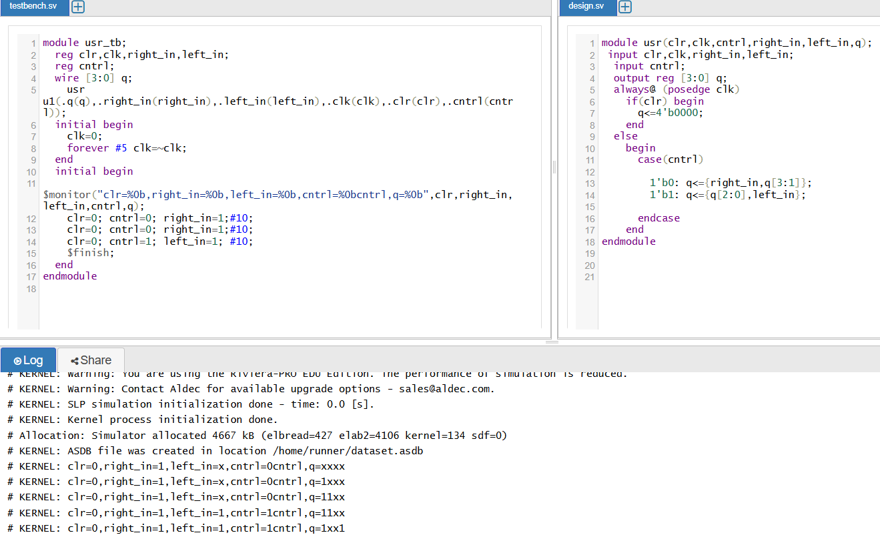
🔄 How It Works
- On each clock rising edge, each bit in the register moves one step along:
  - Output QQQ of stage iii feeds input DDD of stage i+1i+1i+1.
  - New input enters at the first stage; old data exits at the last stage
🧩 Types of Shift Registers
- Serial-In → Serial-Out (SISO)
  - Input and output both serial.
  - Acts like a delay line—output is input delayed by N clock cycles for N-bit register
- Serial-In → Parallel-Out (SIPO)
  - Inputs arrive serially, outputs available at all flip-flops in parallel.
  - Useful for converting serial data streams into parallel format
- Parallel-In → Serial-Out (PISO)
  - Data loaded simultaneously into all flip-flops; output is a serial stream from last stage.
  - Good for transmitting parallel data over single-line links
- Parallel-In → Parallel-Out (PIPO)
  - Data loaded and read out in parallel in one clock.
  - Functions like a general-purpose multi-bit register
- Bidirectional (Universal) Shift Register
  - Can shift left or right based on control inputs.
  - Supports both serial and parallel loading, shifting in either direction

Day 13: To verify Mealy FSM:

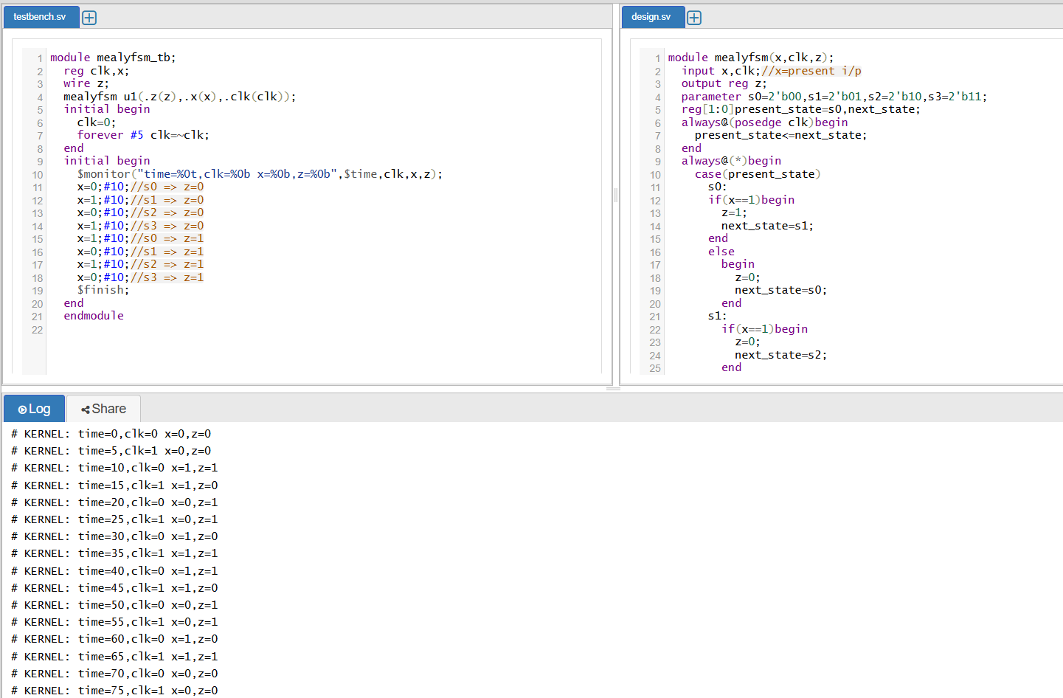

A Mealy FSM offers faster, more compact designs with outputs that respond immediately to both state and input changes. However, you must account for potential glitches and manage slightly more complex logic. Want to see a full Verilog + testbench for a specific Mealy sequence detector? Just say the word!

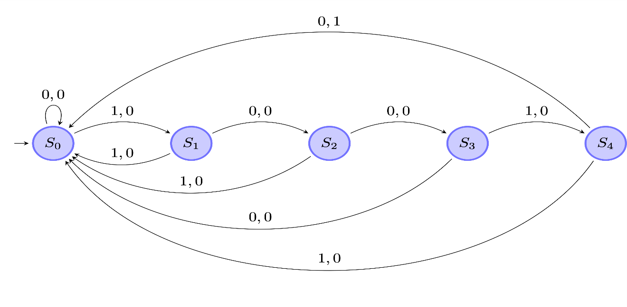🔁 Converting Between Mealy and Moore
- Mealy → Moore: Expand states—each original state may split into multiple sub-states based on distinct outputs
- Moore → Mealy: Outputs previously tied to states now move onto transitions, allowing a reduction in total state count
Day1 4: Decimal to binary conversion:
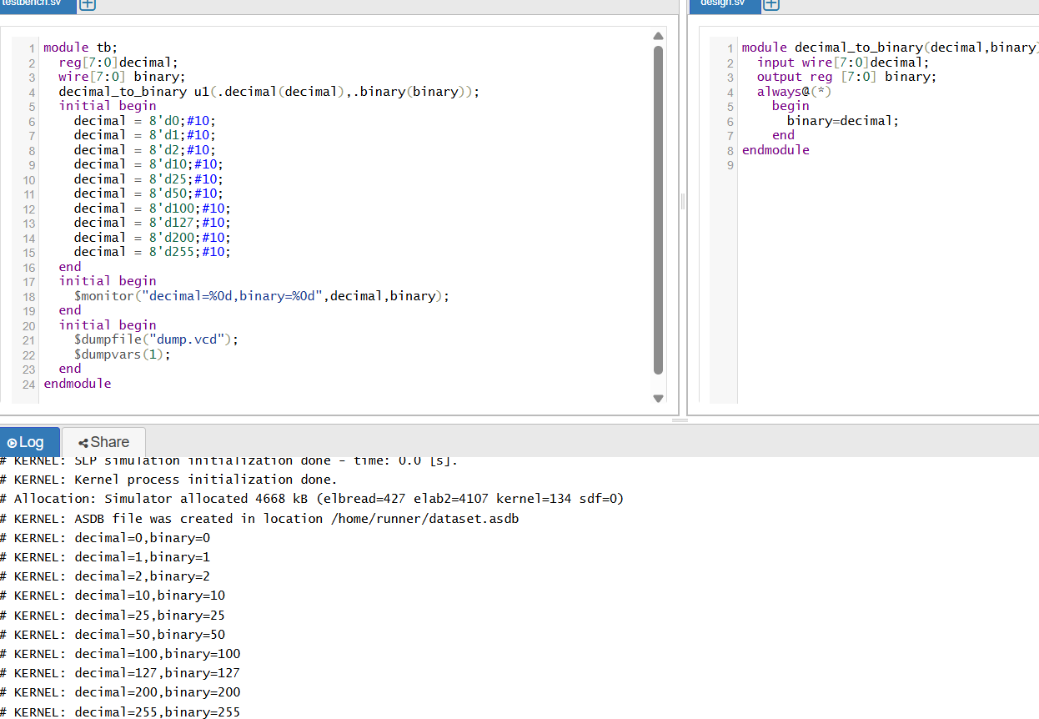
1. Conceptual Method
You're essentially automating the manual “divide-by-2” method:
- Remainder (%2) gives the current least significant bit (LSB).
- Integer division (/2) shifts the number right, preparing the next bit.
- Repeat until the input decimal becomes 0.
- Collect remainders into a bit-vector, assigning each to binary_out[i]
🛠️ 2. Implementation: Procedural always Block
🧩 3. Alternative: Verilog-A / Analog Models
In Verilog-A, similar logic using analog constructs (e.g., floor, voltage transitions)
Day 15: To verify 3:8 Decoder:
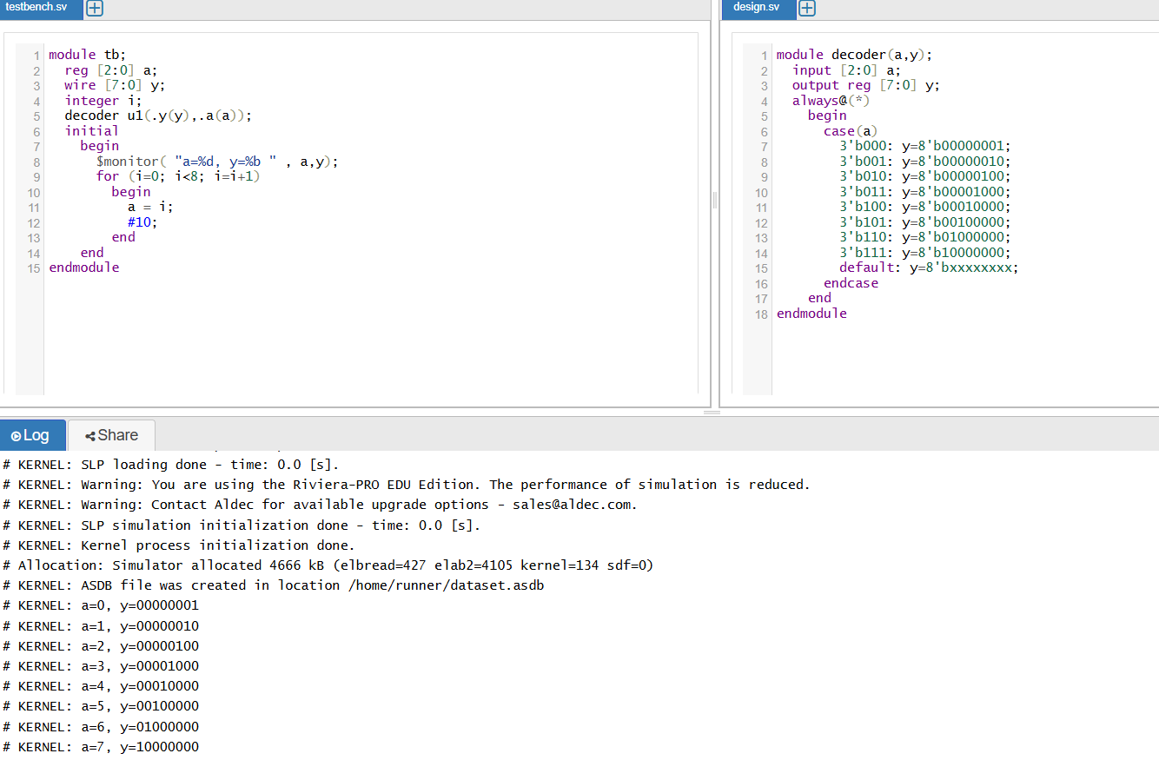

🔧 Logic Diagram
Each output is realized by a 3-input AND gate combining A, B, C (or inverted versions), with a final enable AND.
NOT gates produce Ā, B̄, C̄; then eight ANDs generate Y₀–Y₇. Only one line is active at a time.

🚦 Enable Input Role
- When E = 0, all outputs are low, irrespective of A, B, C.
- When E = 1, outputs reflect the binary input: only the selected Yi becomes high

🛠️ Circuit Construction
- Use 3 input inverters (for Ā, B̄, C̄).
- Wire these and original inputs into 8 three-input AND gates, one for each Yi.
- Optionally, include a separate AND with E, or integrate E directly into each gate

🧩 Applications
- Address decoding in memory and peripherals.
- Demultiplexing data lines.
- Selecting among multiple signal sources.

Day 16: To verify 1:8 De-mux:
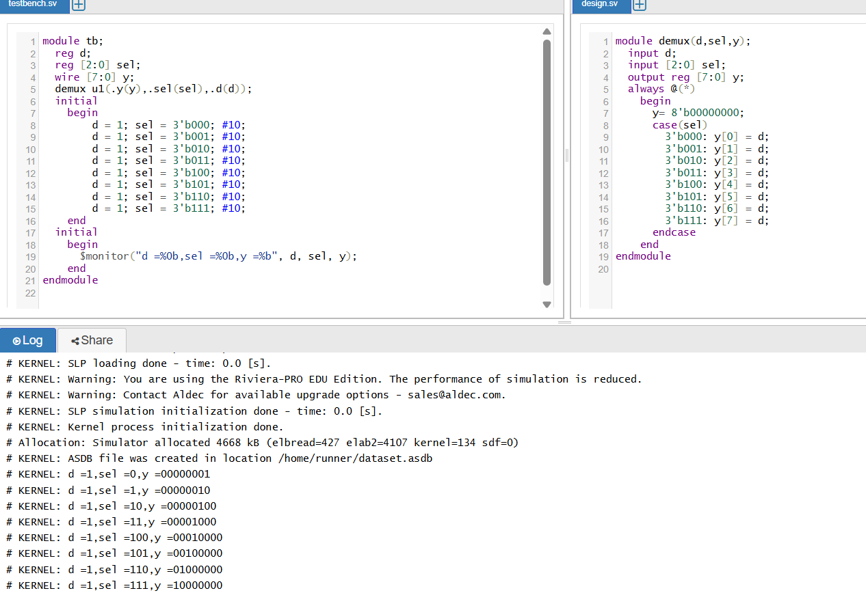
🔧 1. Block Diagram & Operation
- Input: D (single bit), optionally gated by enable E
- Selects: S₂ S₁ S₀ representing a binary index (0–7)
- Outputs: Y₀–Y₇, only one is active at any time
🧮 2. Truth Table
S₂ | S₁ | S₀ | Active Output
0 | 0 | 0 | Y₀
0 | 0 | 1 | Y₁
... |  |  | ...
1 | 1 | 1 | Y₇
Only one output carries D; others are zero .

🧩 3. Boolean Expression
Each output can be expressed as:
mathematica
CopyEdit
Y₀ = D · ¬S₂ · ¬S₁ · ¬S₀
Y₁ = D · ¬S₂ · ¬S₁ · S₀
...
Y₇ = D · S₂ · S₁ · S₀

🔄 4. Implementation Using Smaller Demuxes
You can cascade smaller demultiplexers for structured design:
- Use 1:2 demux on S₂ to choose between upper and lower halves.
- Each branch goes into a 1:4 demux controlled by S₁ and S₀ for 🛠️ 5. Gate-Level Realization
Built using:
- Three inverters for ¬S₂, ¬S₁, ¬S₀
- Eight 4-input AND gates combining:
  - D, S₂/¬S₂, S₁/¬S₁, S₀/¬S₀

Day 17: 4-bit LAU design:
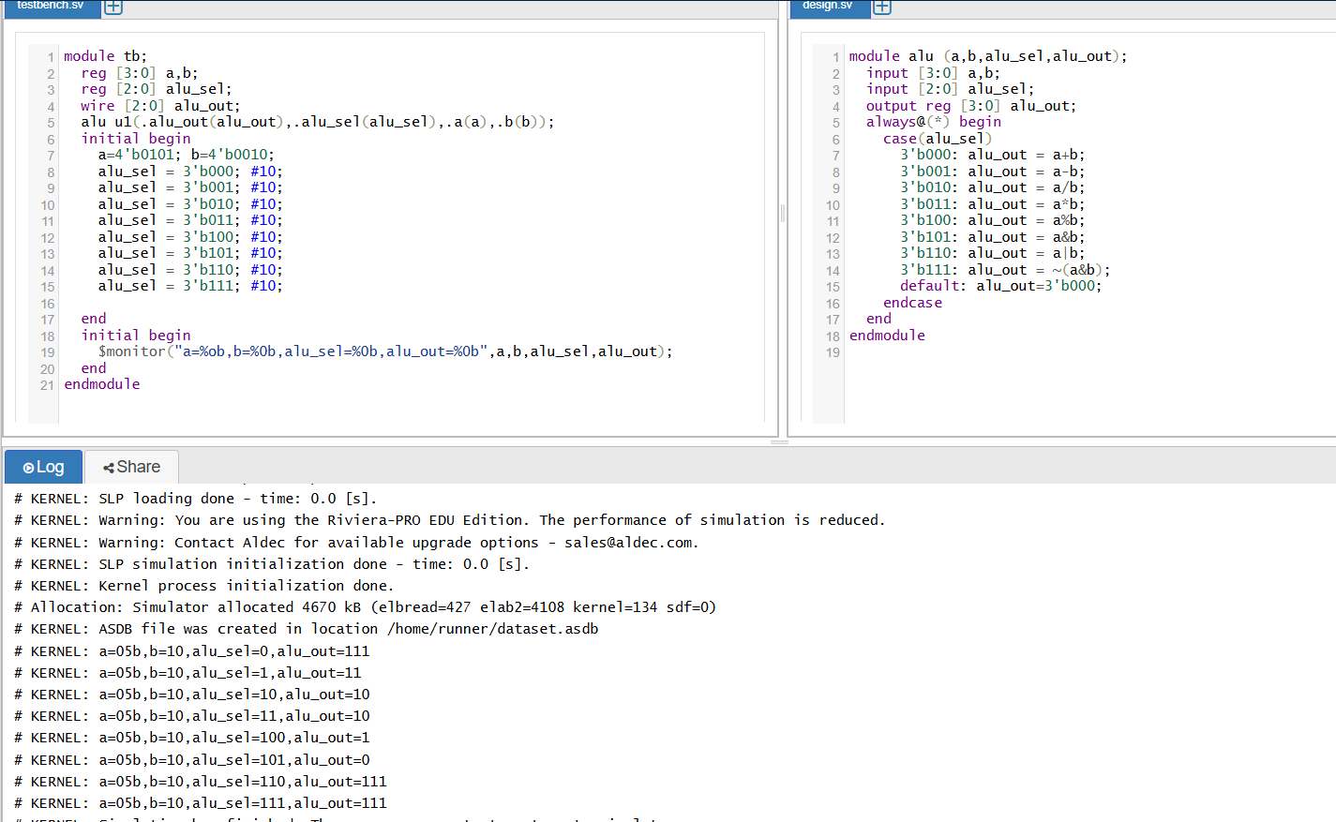
- Arithmetic Unit
  - Contains four cascaded 1-bit full adders (ripple-carry configuration).
  - Supports addition and subtraction (via two’s complement: invert B and add 1 using carry-in)
- Logic Unit
  - Includes bitwise operations: AND, OR, XOR, NOT, etc.
  - Each bit operates independently via simple logic gates
- Multiplexer Stage
  - A multi-input MUX selects the output from arithmetic or logic results based on the opcode select lines
- Control Inputs (opcode)
  - Typical design uses 2–4 control lines to choose functions:
    - 00: AND
    - 01: OR
    - 10: ADD
    - 11: SUBTRACT (or XOR, etc.)
- Status Outputs (Flags)
  - Carry-out (Cout) from the most significant bit.
  - Optional Zero, Overflow, or Sign flags depending on design.
Day 18: Binary to Grey code converter:

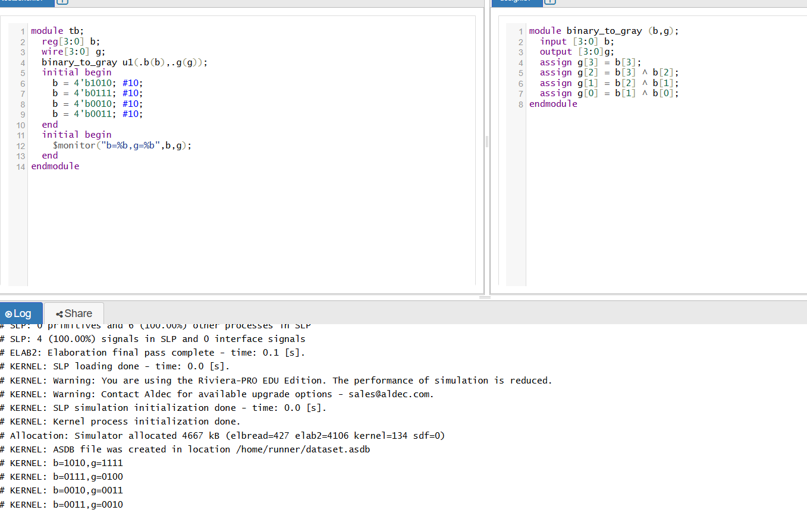

🧩 Binary → Gray Code (n-bit example)
- MSB stays the same.
- For each next bit, perform an XOR between the current binary bit and the previous binary bit.
Mathematically:
- Let binary be b[n-1] b[n-2] … b[0], and Gray be g[n-1] … g[0]
- g[n-1] = b[n-1]
Example:
Binary = 1011
- g3 = 1
- g2 = 1 XOR 0 = 1
- g1 = 0 XOR 1 = 1
- g0 = 1 XOR 1 = 0
→ Gray = 1110

🛠 Why use Gray Code?
- Minimized bit-flip transitions (only one bit changes)—reduces errors from signal noise
- Common in encoders (e.g., shaft/rotary) and ADCs to avoid glitches
- Used in Karnaugh maps and logic circuits for error reduction and easier mapping
Day 19: Gray to binary code converter:

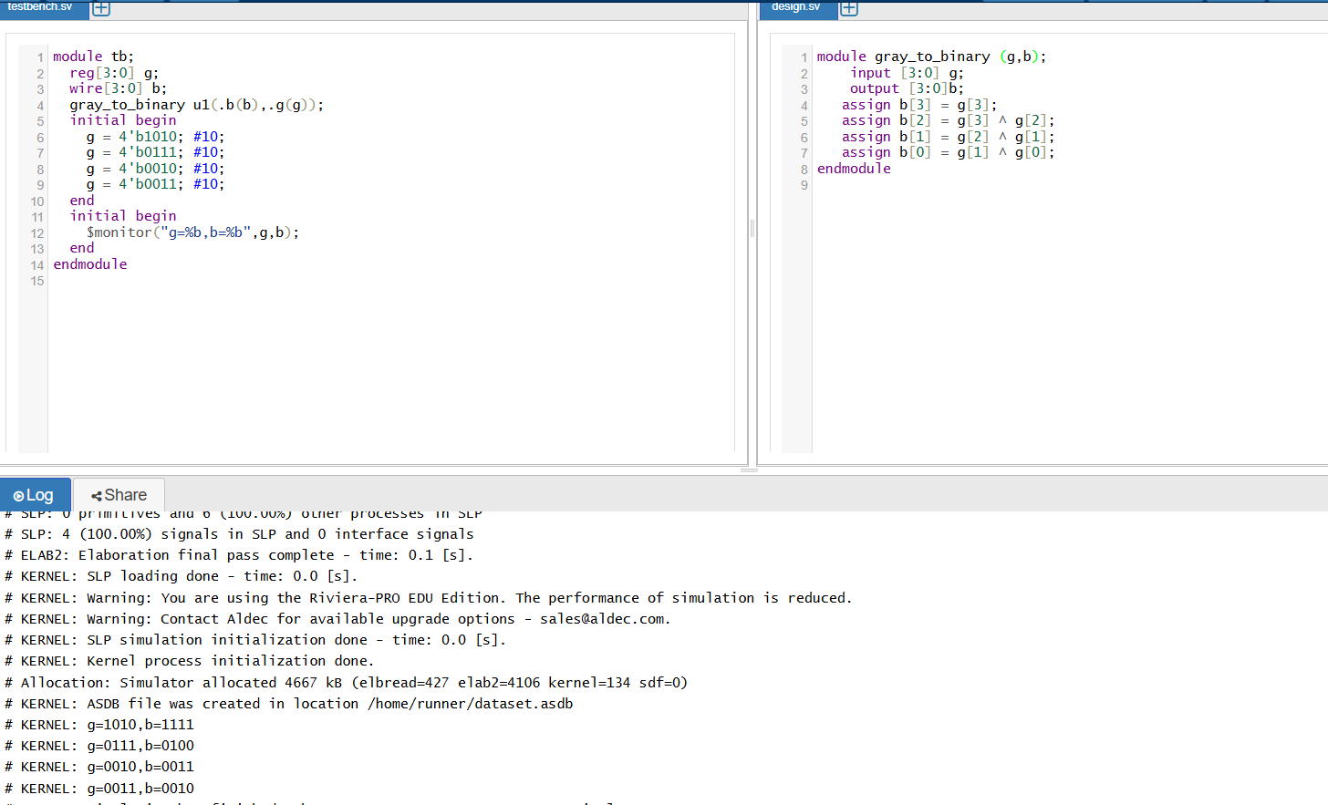

🔁 Gray → Binary Conversion Process
- MSB (Most Significant Bit) remains the same.
  - b[n–1] = g[n–1]
- For each subsequent bit (from next-most to LSB):
  - b[i] = b[i+1] ⊕ g[i]
🛠 Example (4-bit)
Let Gray = 1101:
- b₃ = g₃ = 1
- b₂ = b₃ ⊕ g₂ = 1 ⊕ 1 = 0
- b₁ = b₂ ⊕ g₁ = 0 ⊕ 0 = 0
- b₀ = b₁ ⊕ g₀ = 0 ⊕ 1 = 1
→ Binary = 1001

Day 20: To Verify Logic Gates:

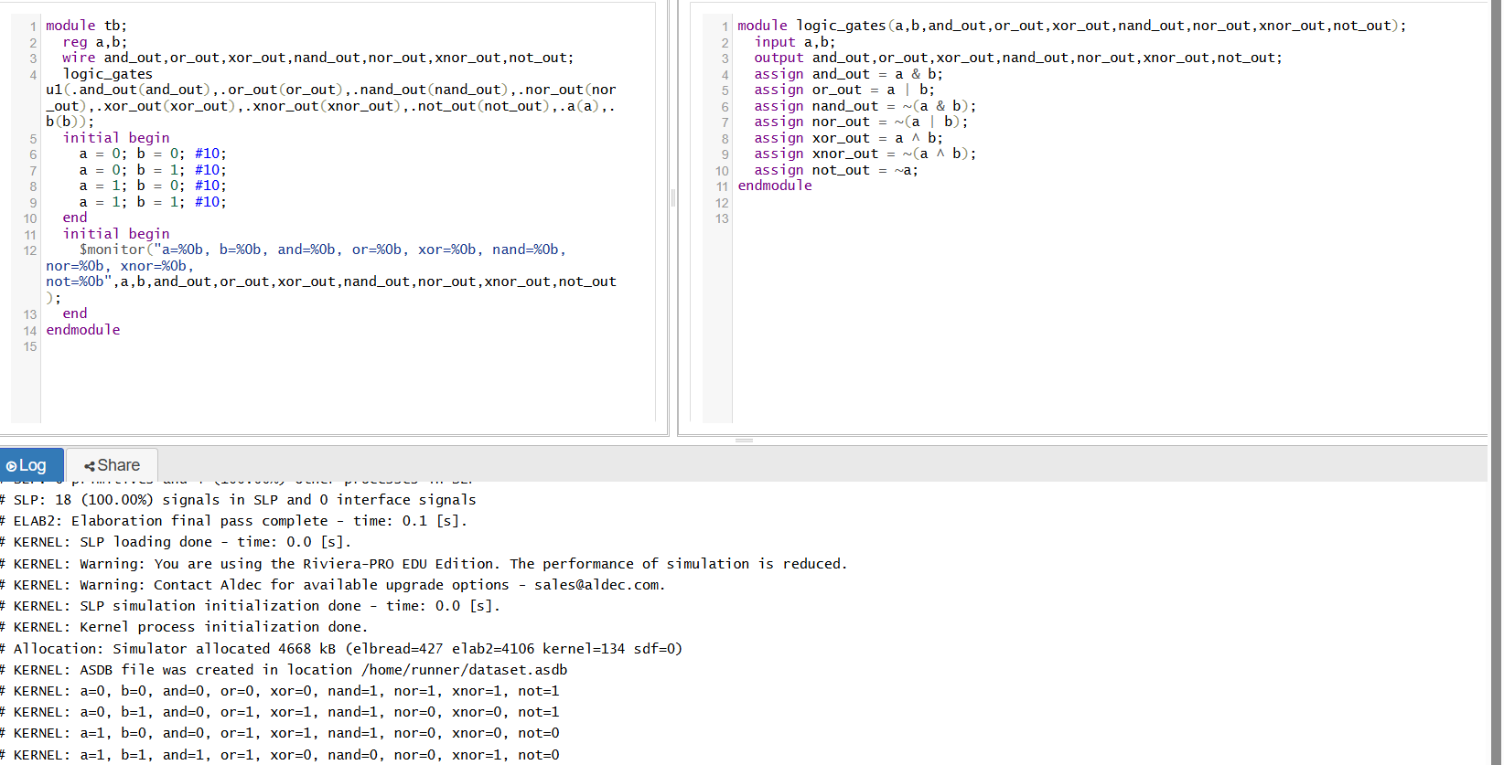
🔹 1. NOT (Inverter)
- Symbol: Triangle with a circle
- Operation: Outputs the inverse of the input
- Boolean: Y=A‾Y = \overline{A}Y=A
- Truth Table:
A | Y
0 | 1
1 | 0
- Use: Bit flipping, generating complements
🔹 2. AND
- Symbol: Flat-front D-shape
- Operation: Outputs 1 only if all inputs are 1
- Boolean: Y=A⋅BY = A \cdot BY=A⋅B
- Truth Table:
A | B | Y
0 | 0 | 0
0 | 1 | 0
1 | 0 | 0
1 | 1 | 1
- Use: Combining conditions
🔹 3. OR
- Symbol: Curved-front shape
- Operation: Outputs 1 if any input is 1
- Boolean: Y=A+BY = A + BY=A+B
- Truth Table:
A | B | Y
0 | 0 | 0
0 | 1 | 1
1 | 0 | 1
1 | 1 | 1
- Use: Selecting among options

🔹 4. NAND (Universal Gate)
- Symbol: AND with inversion circle
- Operation: Opposite of AND: outputs 0 only if all inputs are 1
- Boolean: Y=~(A&B)
- Truth Table:
A | B | Y
0 | 0 | 1
0 | 1 | 1
1 | 0 | 1
1 | 1 | 0
- Use: Can implement any logic function

🔹 5. NOR (Universal Gate)
- Symbol: OR with inversion circle
- Operation: Opposite of OR: outputs 1 only if all inputs are 0
- Boolean: Y=~(A|B)
- Truth Table:
A | B | Y
0 | 0 | 1
0 | 1 | 0
1 | 0 | 0
1 | 1 | 0
- Use: Also functionally complete

🔹 6. XOR (Exclusive-OR)
- Symbol: OR with extra curved line
- Operation: Outputs 1 if inputs differ (odd number of 1s)
- Boolean: Y=A⊕B
- Truth Table:
A | B | Y
0 | 0 | 0
0 | 1 | 1
1 | 0 | 1
1 | 1 | 0
- Use: Parity checks, adders, toggles

🔹 7. XNOR (Exclusive-NOR)
- Symbol: XOR with inversion circle
- Operation: Outputs 1 if inputs are the same (even parity)
- Boolean: Y=~(A⊕B)
- Truth Table:
A | B | Y
0 | 0 | 1
0 | 1 | 0
1 | 0 | 0
1 | 1 | 1
- Use: Equality detection

🔁 Gate Categories
- Basic: AND, OR, NOT
- Universal: NAND, NOR (can build any other gate)
- Derived/Special: XOR, XNOR

✅ Quick Reference Table
Gate | Boolean Expression | Output = 1 When...
NOT | A | A = 0
AND | A⋅B | A = 1 and B = 1
OR | A+B | A = 1 or B = 1
NAND | ~( A&B) | not(both=1)
NOR | ~(A|B) ​ | both = 0
XOR | A⊕B | inputs differ
XNOR | ~(A⊕B)​ | inputs equal



